**ELB (Elastic Load Balancer) - 02nd September 2024 Priti Shelke**

1. Create two instances in different zone of (ap-south-1)

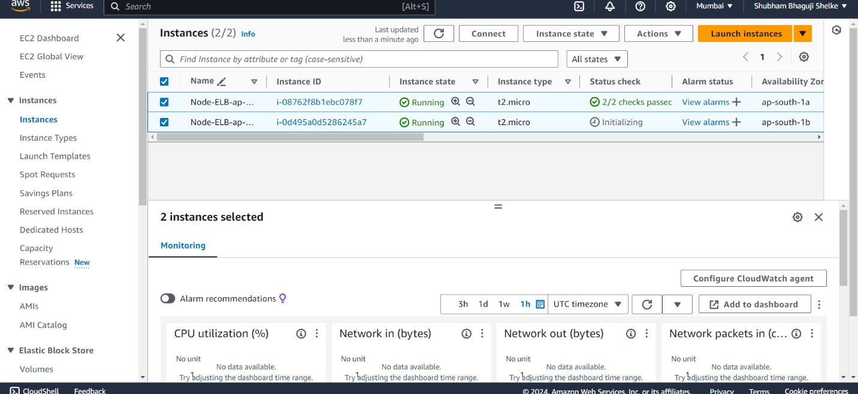2) 2) Creating Load balancer for running two instances

i. create classic load balancer

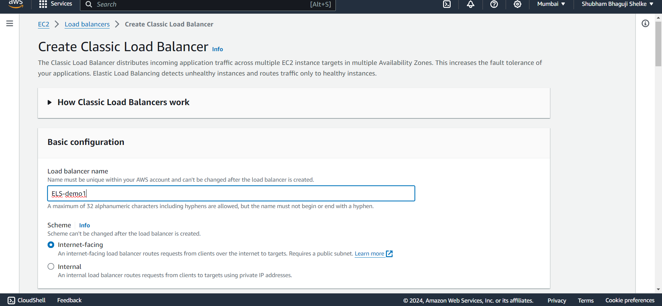

ii. Map the network for instances

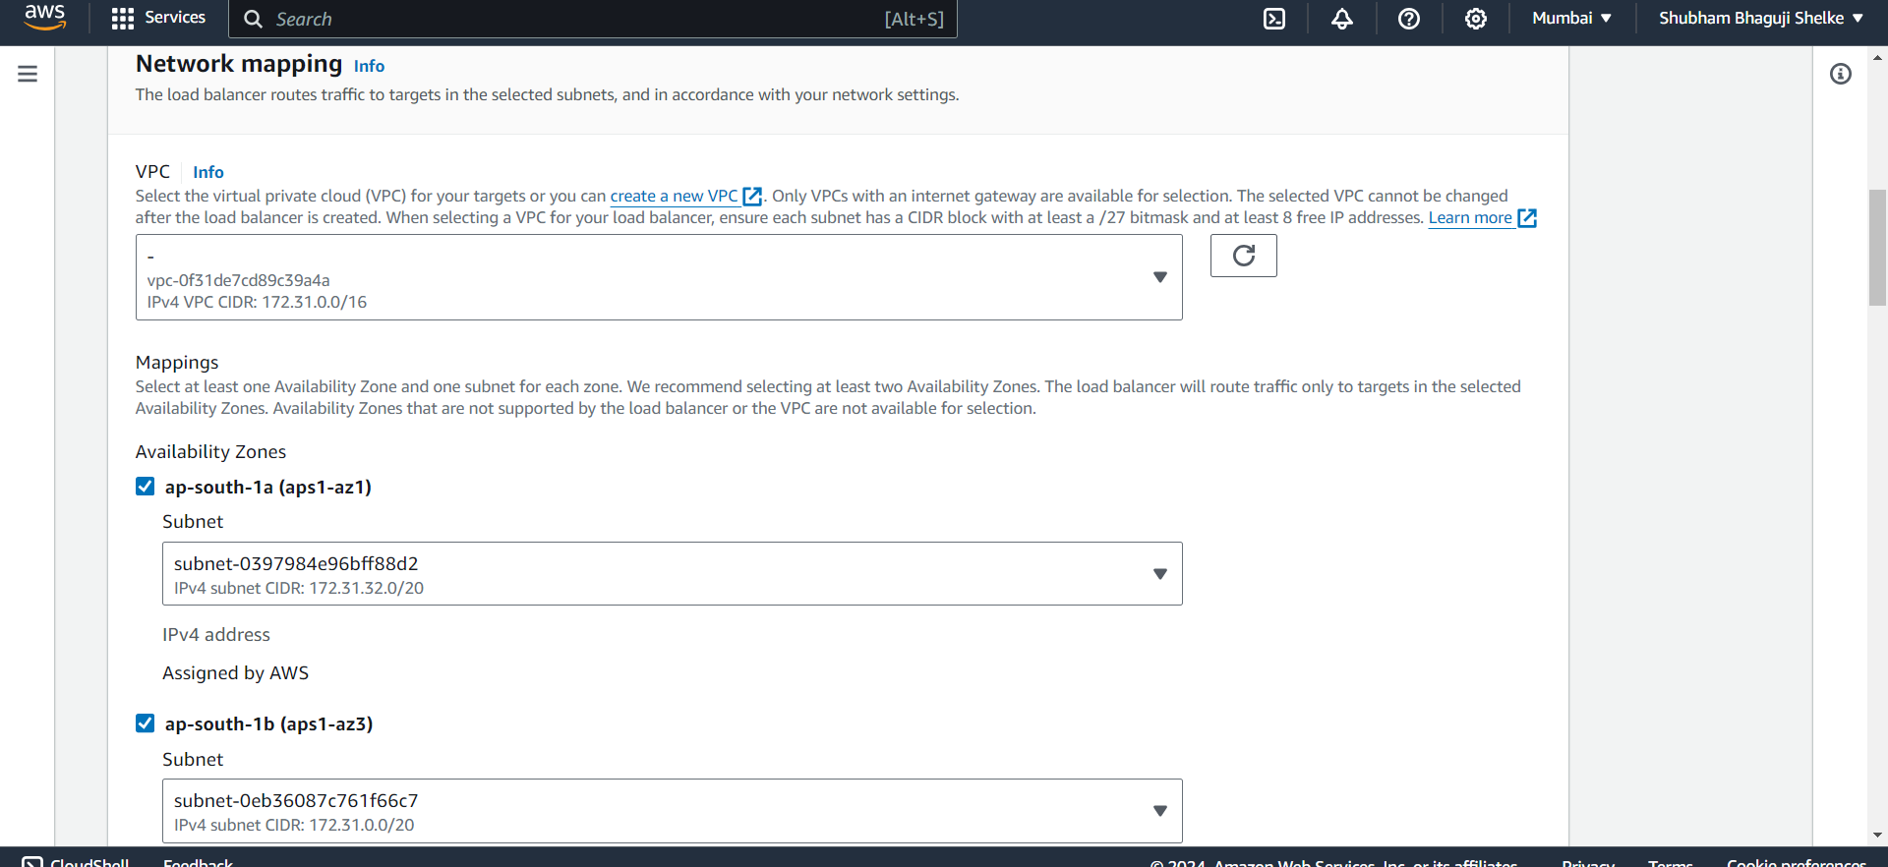

iii. attached instance to load balancer

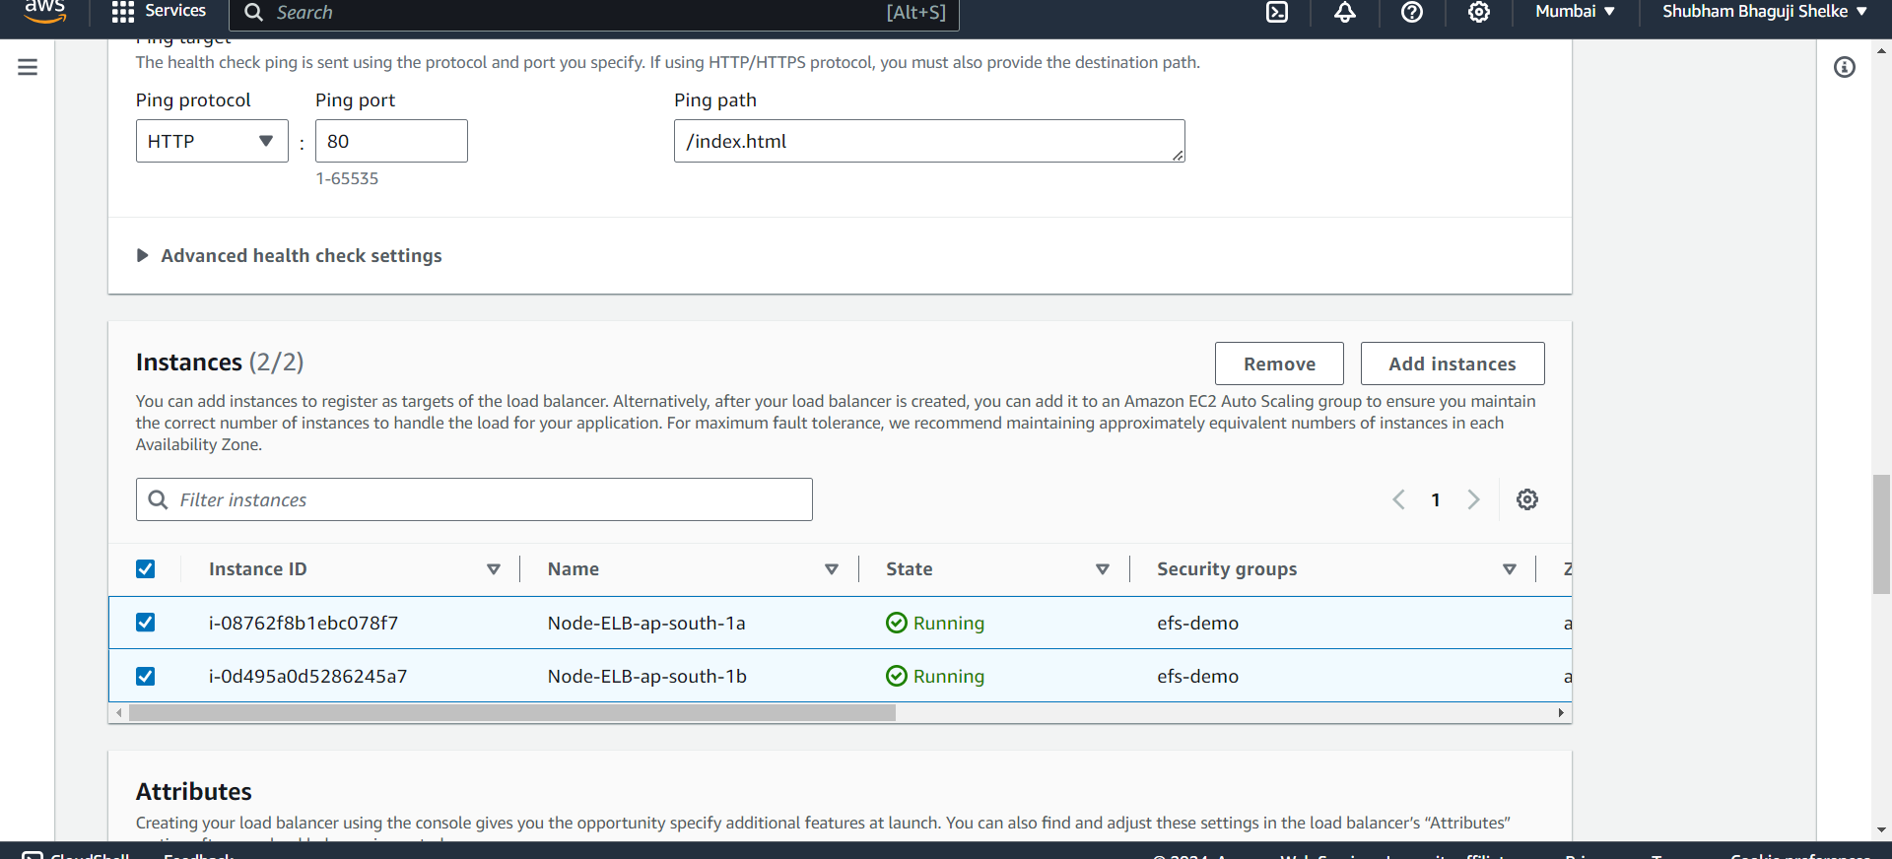

iv. Successfully created load balancer

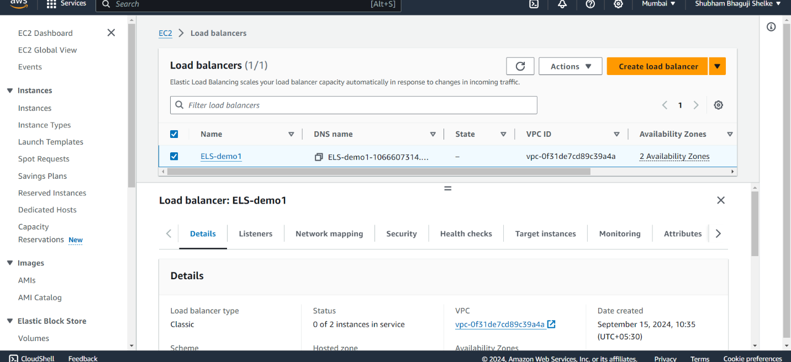

v. both instances in-service status

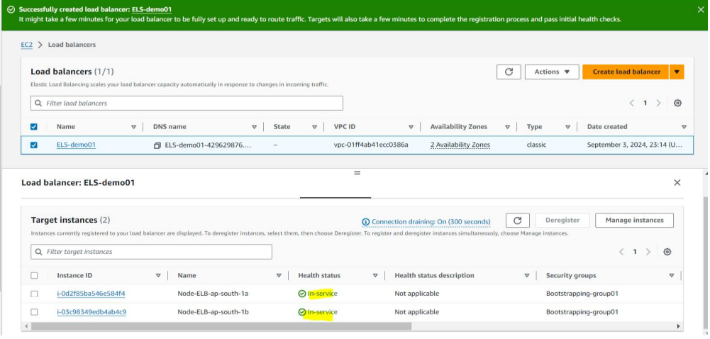

3. copy dns name and paste in chrome

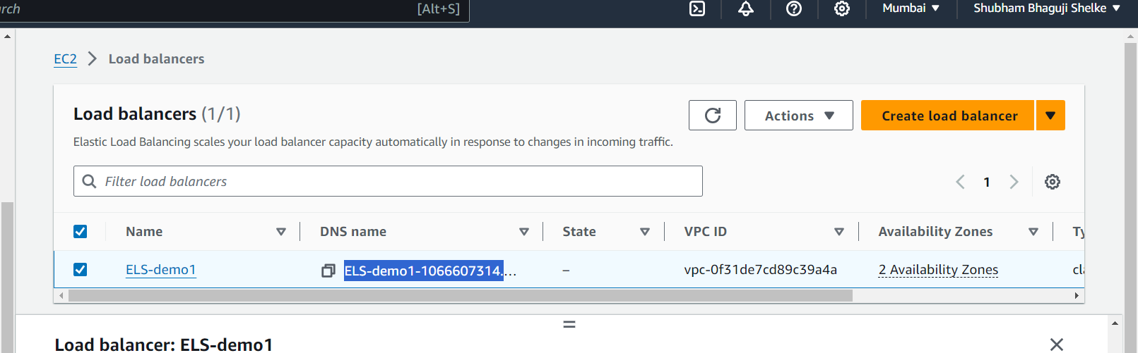

4. output of index.html file

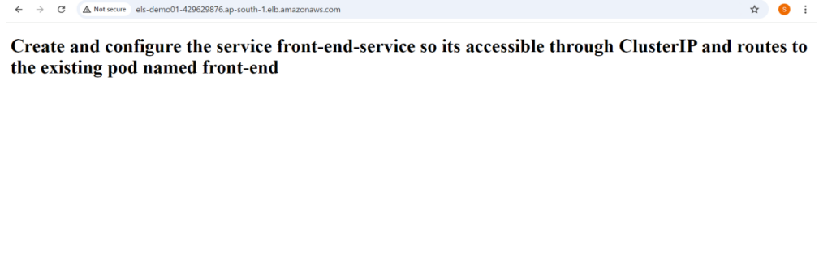

5.output of healthcheck.html file

